Diagnosing malaria in resource limited settings, why and how?

Plasmodium falciparum malaria in western Kenya

Emily Tegnell
01-04-2014
Studenten nummer: 3551288
6 weken Keuzeonderwijs master jaar 2

Introduction
Although global morbidity and mortality have decreased substantially, malaria still kills about 2000 people every day. The most affected being children in Sub-Saharan Africa. Malaria is a protozoan disease caused by five different species of the genus Plasmodium and is transmitted by Anopheles mosquitoes [1]. Throughout the years there has been a proven overdiagnosis of malaria which has resulted in resistance and sometimes denying other causes of fever. Big investments have been made to limit the disease [2]. As an article in the Lancet states the enthusiasm for malaria elimination has resurfaced [1], the malaria news in Kenya reports setbacks [3]. A pessimistic article where the future of malaria is described as “the killer disease that is as aggressive as ever” was published in a daily newspaper in Kenya in March 2014. They report that even with the massive investments done, still 60% of the population in Kenya live in high-risk areas for malaria infection. Between 2000 and 2010 the incidence of malaria even increased, mainly due to the exponential growth in population. In Kenya, now, a multi sector malaria strategy has been developed and is running from 2009 until 2017 to deal with the disease [3]. The lancet’s article is more optimistic describing the results of vector control, research on vaccination and even irradiation in some countries as Turkmenistan and Morocco [1].
In this article the diagnostics of malaria and the practices and needs of these in different parts of the world will be presented and discussed. Diagnostics in a resource limited setting (the region of western Kenya) as well as the developed world (The Netherlands) will be presented. The resource limited settings used for comparison are the practices of Rotary Doctors The Netherlands and Sweden in western Kenya (RDN and RDS). For information of a more developed country guidelines of the CDC have been used as well as information from the laboratory in the University medical centre Utrecht (UMCU). In particularly the choice of using either a rapid diagnostic test (RDT) or microscopy in a resource limited setting will be discussed. First the epidemiology, clinical features and treatment of uncomplicated malaria in men, children and nonpregnant women will be presented.

This article will focus on the infection of Plasmodium falciparum (Pf). Plasmodium is subdivided into the subgenus Laverania and Plasmodium. The Plasmodium falciparum belongs to the subgenus plasmodium and is the main species in subtropical areas. The rest of the subtypes of malaria parasites (mps) are part of the subgenus Laverania. Pf malaria is sometimes also referred to as subtertian or malignant tertian malaria and it causes 80% of all malaria worldwide [4]. In the western part of Kenya Pf is responsible for almost all the infections with malaria. It is also the only kind of malaria that can give high, life threatening densities of parasitemia [5]. There are variations in the Pf which depend on the geographical location and they will have effects on the vector susceptibility, human infection pattern, morphology drug susceptibility and antigens [4].

Epidemiology
98.2% of the malaria infections in Kenya are caused by p. falciparum [5]. It has been showed to be difficult to compare and rapport the risk of infection of malaria in a certain area. Here the term entomological inoculation rate is used. It is defined as the number of bites by infected mosquitoes per person per unit of time and is so a measurement for the intensity of transmission of malaria. The way of calculating this is not standardized and will depend on factors as the population density and other population differences [6]. What can be stated is that the malaria in western part of Kenya is endemic with an annual entomological inoculation rate of between 30 and 100 [5]. High infectious areas have an altitude below 1300 meters and are caused by a humid climate and rainfall in these areas. In parts of Kenya which are described as epidemics prone areas, there is a short malaria seasons during the rainy season or occasional periods when the weather is favorable for the vector of the parasite. In some parts of Kenya, like in Nairobi malaria has a very low risk due to low temperatures. The low temperatures do not allow the plasmodium to complete the sporoganic cycle in the vector. With rising temperature in Nairobi malaria will be more common and increase in these areas (figure 1) [5, 7]. In The Netherlands there are about 200 malaria infections seen per year. It is presented exclusively as an imported disease where patients have been visiting areas with malaria. Even if there are more people going to malaria-endemic countries the importation of malaria is declining. Approximately half of the travelers are protected when going, using malaria prophylaxes [8].

Clinical features
Malaria is classified as uncomplicated, complicated or subclinical, depending on the severity of the disease. The severity is often, but not always, correlated to the concentration of parasites in the blood. The uncomplicated malaria will present with fever and possibly chills profuse sweating, muscle and joint pains, abdominal pains and diarrhea, nausea, vomiting, irritability and refusal to feed. Severe malaria is accompanied by life threatening symptoms as alternations in consciousness, convulsions, pulmonary edema and severe anemia [5]. Subclinical malaria (i.e. malaria without symptoms) has been underestimated. Small foci of stable transmission act as reservoirs when people with immunity for malaria don’t develop symptoms and can carry the infection for several months and years [1].
In endemic settings individuals with acquired partial immunity due to repeated exposures may have asymptomatic parasitemia of varying levels. No existing diagnostic test can distinguish between parasitemia with or without symptoms. Thus, detection of malaria parasite in a patient does not necessarily mean that the current illness is due to malaria, it could be a coincidental finding [1].

Management
Prevention of malaria is an essential part of the management of this widespread disease. Bed nets, repellants, prophylactic treatment (chemoprophylaxis) and information of transmission and symptoms has been a big part of reducing the prevalence of malaria [1]. Treatment for malaria should, according to the WHO guidelines [9], as well as the Kenyan guidelines for management of malaria [5], always be preceded by accurate diagnostics. If, for any reason, this is not possible treatment for malaria should never be refused to anyone if it is suspected [5]. The possibilities of diagnosing malaria are thoroughly described in the next chapter.

Treating an infection of malaria is done with antimalarials. These drugs can also be used to prevent malaria in travelers, as chemoprophylaxis, or in treating certain groups in endemic regions prophylactically, known as intermittent preventive therapy. Current practice in treating falciparum malaria is with a combined therapy. This combination therapy reduces the risk of treatment failure, side effects and the risk of developing resistance [10]. Due to over-diagnosis and unregulated drug resistance there is an increasing resistance to quinoline. In vitro testing of resistance is possible by cultivating the Pf. This can only be used for epidemiological studies because it cannot predict a patient’s clinical response to treatment [4].

First line treatment of uncomplicated malaria in high resource countries depends on which specie is suspected and from which geographical area the patient has traveled. For Pf infections acquired in areas with chloroquine resistance, atovaquone-proguanil (malarone) or artemether-lumefantrine (coartem) is advised [11]. The coartem is one of the artemisinin derivate combinations (ACTs). Overall no RCT has been proven to be superior o any other. Quinine based regimen in combination with doxycycline or clindamycin is avoided due to more side effects than with other medication. Mefloquine (Lariam) in combination with artesunate or doxycycline is also a treatment option. Other potential useful drugs are limited by resistance and side effects [10].

The recommended first line treatment according to the Kenyan guidelines is artemeter-lumefantine for 3 days, 2 times a day, where the second dose is taken 8 hours after the first. For children less than 24 kg the Kenyan guidelines recommend the disperse tablets. The first treatment should be given directly at the clinic and information about further treatment should be given. Vomiting within 30 minutes indicates that the dose should be repeated. Together with the AL an antipyretic (paracetamol) should be given and the nutrition status should be controlled [5].

The treatment used in RDN/RDS is coartem, with the doses depending on weight. There are no disperse tablets. For children the tablets will be given with instructions to crush the tablet and ingest it with water. There is information given about the importance of fulfilling the treatment, beginning at once and taking the second dose after 8 hours.

The biggest difficulties with the compliance in Kenya experienced by the local staff of RDN concerns the dose and the time of intake. Even after careful information from the pharmacist children will sometimes be under dosed when the parent thinks the dose is too big and adults will be overdosed to be sure they get better. As the custom is to take medication only in the evening and morning, many patients, despite of the information given, will wait until evening, or sometimes to the next morning, with taking the medication.

The coartem is bought from MEDS (Mission for Essential Drugs and Supplies) in the case of RDN/RDS. The price is 2100 Kenyan Shilling (KES) for 30 treatment sessions. This means a price of 70 KES (0.60 euro) per treatment session for a full dose. The recommended selling price of the government is 240 KES (2.0 euro) in the pharmacy [12]. At RDN/RDS, once the fee of 100 (0.80 euro) or 50 KES (0.40 euro) (above or below 5 years) is paid for the evaluation, the laboratory testing and medication is included. Due to the free market in Kenya, according to the medical staff at RDN, it is difficult to find the antimalarial drugs for the right price. The price will be anything from 500 KES (4.20 euro) and up. This is because there is no enforcement by fining of the salesperson even though this act is prohibited by law. A second problem reported by the medical staff in RDN and RDS is the question about the reliability and quality of the AL bought cross counter. It is not certain that the medication is accurate or effective.

Treatment failure is when the symptoms of malaria persist after 3 days with accurate medication, or when an infection occurs again within 2 weeks. Treatment failure does not mean drug resistance. The compliance or altering pharmacokinetics in the individual patient should be considered. The failure should be confirmed with diagnostics for malaria and if it is still present it should be treated with a second line treatment: dihydroartemisinin-piperaquinine(DHA-PPQ) [5]. Management of severe, or complicated, malaria falls beyond the reach of this paper.

DIAGNOSTICS
An accurate and quick diagnosis of malaria is critical for the patient’s individual prognosis as well as for the investigation of further spreading of malaria on an epidemiological level. The diagnostics are important for epidemical research purposes, testing the efficiency of antimalarial drugs and vaccines and testing blood bank blood. However, foremost diagnostics are essential for the implementation of appropriate treatment for the individual patient [10]. To avoid expensive overtreatment, developing resistance and unwished side effects the WHO guidelines [1], as well as the Kenyan guidelines for management of malaria [5], state that the treatment of malaria always should be preceded by accurate diagnostic testing. In cases where there are no diagnostic tools for malaria, all patients with fever in an area with a high prevalence of malaria should still be treated [5, 1]. In Kenya, the diagnostic test should be used for all patients who reports fever in the last days [5]. In the CDC guidelines, for practices not in endemic areas, it is recommended that any febrile person who traveled to an area with known malaria transmission in the past several months preceding symptom onset, should be tested [11].

Types of tests
With the diagnostics of malaria it is intended to establish, in the first place, the absence or presence of the infection, but also the quantity of parasites in the blood and the type of mps. Depending on epidemiology of malaria infection, the geographical region and the available resources different characteristics for the test to use are important. The available possible tools to suspect or prove a malaria infection are the clinical presentation, light microscopy, rapid diagnostic tests (RDTs) and molecular methods (mainly PCR). The golden standard to diagnose malaria is by light microscopy [10].

Clinical signs
Several studies have been done investigating the accuracy of diagnosis set only on the clinical features [10]. In one review it was seen that the clinical signs of malaria and their specificity for malaria was highly site-specific. In the rural areas of Tanzania, where the prevalence and population would be comparable to western Kenya, the most specific clinical feature was intermittent fever 2-3 days. The sensitivity was 73% and the specificity was 98%. Even if the absence of cough, presence of paleness and an enlarged liver or spleen where associated with malaria. None of these symptoms alone or combined had a high enough sensitivity or specificity to be used for diagnosis. The review did show that an algorithm can better be used in areas with high prevalence than in areas with a lower prevalence: the odds of wastage of drugs increased by 1.49% for every 10% decrease in prevalence [13]. Thus, with the evidence provided, the clinical presentation and so suspicion of malaria is not enough for diagnosis. There are no pathognomic clinical signs or symptoms for the malaria.

Laboratory tests and light microscopy
As previously stated the golden standard to diagnose malaria is by light microscopy. This should be done on a thick blood smear, preferably accompanied by a thin blood smear. There is no laboratory test result that is specific for malaria, although a mild to moderate anemia is often present. Along with the confirmation of mps though, the laboratory monitoring of complications of malaria such as anemia and hypoglycemia should be done. Also a number of other measurements in blood and urine should be monitored. This is to detect problems that might accompany malaria, such as kidney failure, or problems associated with its treatment. Presence of glucose-6-phosphate dehydrogenase can cause a hemolysis in a patient when given certain antimalarial drugs [4].

A blood smear, stained with Giemsa stain examined under a light microscopy is the standard tool for the diagnosis. In resource limited settings the Field’s stain will be used instead, because of it being more stable [10] and quicker than the Giemsa stain [4]. The field’s stain is a water-based Romanowsky stain A and B. The Giemsa stain is an alcohol-based Romanowsky stain. It requires buffering as the result will depend on the concentration as well as the pH. The result is also affected if any water enters the stain. Giemsa will give the best stains to thin films and the differentiation of different mps can be done very accurate in the thin smear. When using the field stain the thick smear is held in the A stain for 5 seconds, the B stain for 3 seconds and in between cleared in clean water. The field’s stain of the thick smear is not fixed and the parasites will not be killed, neither will viruses or other pathogens. Whenever possible the stain should therefore be treated with acetone. On examining the smear good illumination is essential. It should be viewed with immersion oil in 100 times enlargement. The blood should be collected in a plastic bulb pipette, used at once and put on an area of 15x15 mm grease free microscopic slide. It should be possible to see, but not to read, a newspaper through the sample. Label the slide and let air-dry in horizontal position. Treat the slide with acetone for 10 minutes prior to staining to avoid laboratory acquired infection. Stain the slide at a pH of 7.1-7.2 using a field’s stain or a Giemsa stain [4].

Trypanosomes, microfilariae and borreliae are also possible to identify in the smear even if it is easier in a thin smear. A marked reticulocytosis in the smear can be an indication for sickle cell disease. In the leucocytes there can sometimes be malaria pigment seen. This is haemozoin and is the end product of the mps when it breaks down hemoglobin. When the parasites are not found in the blood film, the blood can be centrifuged for a closer examination [4].

Reporting should reveal if the test is positive, negative and the density of mps in parasites per 200 white blood cells by using a two hand tally counter. The severity can also be given in plus signs. This should be avoided as it is less subjective as giving the density. The blood films can be made from capillary blood but it is also possible to take EDTA blood and examine within 30 minutes [4, 5].

In comparing the microscopy with PCR in an article from 2013, the sensitivity of microscopy was 89.4% whereas the specificity was 100% [14]. In another recent survey, microscopy was reported to detect about 75% of malaria in high transmission areas [17]. In resource limited settings the sensitivity and specificity are often lower than in high resource research laboratories. Errors is also an issue in laboratories with limited exposure to tropical infections because lack of routine. Microscopy will give more errors, and cannot be reliable, when trying to detect very low densities of mps. This can be partly because of sequestration of the mps although densities as low as 4 to 20 parasites per micro liter can be detected by well trained lab technician [10].

The most common cause for a false negative result is when an antimalarial drug has been used before diagnostics are done. This leaves few parasites to detect (fig. 2). The trophozoites of resistant strains are difficult to recognize as they look thick and distorted [4].

At the dispensary in Mundika, western Kenya, the RDN work with primary health care and use light microscopic testing to diagnose malaria. The microscope is well used, 2nd hand and does not have a built in lamp which means that daylight or an electric lamp is needed to use the microscope. The Field’s stain used is made from powder by the lab technician and will be used for 4 weeks. The lab technician costs 22 000 KES (180 euro) per month. The procedure of diagnosing malaria is by thick smear only. The density of parasites is approximated to number of parasites per 200 white blood cells and the approximated density is reported together with plus signs indicating the severity of the parasitemia. 6-100 mps per 200 white blood cells this will correspond with one plus sign. Up till 600 it is 2 plusses, from 600-2000 gives three and the highest quantities of mps (more than 3000) gives 4 plusses. There has to be taken into account that the stain does not color all the parasites properly and that therefore this has to be taken into account when giving the density. There will be 4-5x more parasites than seen.

In high resource countries patients suspected of having malaria should be urgently evaluated. Blood films need to be read immediately so off-hours, qualified personnel should be on-call. Non-immune individuals may be symptomatic at very low densities of parasites. The first blood smear may therefore be negative. Every 12-24 hours they should be repeated for at total of negative 3 sets to rule out malaria. RTDs should only be used if there is not an in house on-the-spot microscopy available [11]. The standard procedure when there is a suspicion of malaria at the UMCU is a three day in a row thick and thin smears looking for the parasite. The first day there will also be a RDT done. The Binax Now, ICT Malaria test is used. The thick stain is taken from venous blood in EDTA, dried and colored with Giemsa stain. 200 viewpoints are viewed, or until positive to determine the set the diagnosis. The thin smear is used to determine the sort of malaria and the percentage of parasites. The appearance of the blood smear after Giemsa coloring will depend on how old the coloring is and how it was made. The pH will change and with it the characteristics of the coloring. In the UMCU a standard Giemsa color is made by the lab and so it will always be the same.

Rapid diagnostic test (RDT)
Rapid diagnostic tests (RDTs) where developed in the 1990s and are constructed to detect antigens against malaria [10]. They are immunochromatic tests based on antigen detection for a certain parasite. There are two types of antigens used. Histidine-rich-protein 2 (HRP2), which is specific for Pf, or the parasite lactate dehydrogenase (pLDH), which can differentiate between falciparum and non-falciparum malaria[5].There are also systems to recognize parasite antibodies produced by the host; however these are less useful for the diagnosis and will therefore not be further discussed. Most RDTs will not differentiate between different species of malaria and they will always give merely a qualitative result and do thus not reveal the density of mps. There are more than 200 different RDTs and depending on different factors, a RDT can be chosen [10]. The RDT are not recommended for follow up. They will remain positive up to 3 weeks after antimalarial treatment has been finished [5].

In the RDS setting the cassette of Paracheck-Pf® (Orchid Biomedical Systems, Goa, India) ver. 3 is used. They are delivered from Orchid, to MEDS in Nairobi before sold to RDS. It is bought for a price of 109 KES (0.90 euro). Paracheck is an in vitro, rapid qualitative immunoassay for the determination of HRP-2 in whole blood for the diagnosis of falciparum malaria in individuals with signs and symptoms consistent with malaria infection. HRP-2 is a water soluble protein that is released from parasited erythrocytes of effected individuals. The test is not intended to screen persons without symptoms or to follow up the treatment. It is further recommended to include internal positive and negative control samples before use. The internal study reports a sensitivity of 99.35% and a specificity of 99.05%. It is to be stored in 4-45 degrees and is sensitive to sunlight. According to the, with the product delivered, information the disposal and handling of potentially infective material a standard bio safety guidelines should be followed [15]. It is not clarified how this study has been preformed. Field evaluations are essential to obtain operational data as the heterogeneous performances of these types of tests depend on local factors, for example presence of other diseases, cross-reactivity with human antibodies and mutations in the parasite but also exposure of the Paracheck to high temperatures and high humidity [16, 17]. The product information of Paracheck states that a negative result should be confirmed with a blood slide. A positive result should be verified with a confirmation test [15].

RDTs should only be used where microscopy is not available. According to the WHO standards in 2006 a RDT should have a sensitivity of 95% at a parasite density of 100 parasites per micro liter [18]. The updated WHO recommendations for procurement of RDT were presented in 2012. Here a detection score should be at least 75% at 200 parasites per micro liter [9]. In several studies the sensitivity and specificity of the Paracheck have been evaluated. In one study 209 children aged 6 months to 12 years with symptoms suggestive for non severe malaria where enrolled in Nigeria. Microscopy with Giemsa stained thick blood films where the golden standard. The sensitivity of Paracheck was found to be 86.21% and the specificity was 81.98% at parasite densities varying from 40 to 203,883 parasites per micro liter. All the false negative results had densities below 10,000. It is argued in the article that PCR would be a better golden standard [16]. In a second article the Paracheck was compared to microscopy, and the negative results from microscopy were confirmed with a PCR. 436 samples were analyzed and the sensitivity and specificity were set to 85.7% respectively 86.0 % in all concentrations. Again the test preformed less at low densities but the sensitivity did score over 95% at more than 500 parasites per micro liter [16]. In an article with 3,339 participants were enrolled, where the PCR was used as the golden standard the sensitivity and specificity of Paracheck was reported to be respectively 72.8% and 94.3%. In this survey Paracheck even preformed better than the microscopic test. It must be noted that this survey was performed during a field-based prevalence survey, and not on patients with suspected malaria. In the article it is also highlighted that a more adequate expert performance of microscopy had given better results than the specificity of 60.0% [17]. In all surveys the Giemsa stain was used for the blood slides.

As mentioned above, at the UMCU the first day there will also be a RDT done along with the blood slide. The Binax Now, ICT Malaria test is used. It is a test to detect HRP-2 and pLDH. The Binax Now is kept in 3-8 degrees and exactly 15 micro liter blood is added from an EDTA blood sample. The sensitivity and specificity of the Binax is, when using microscopy as golden standard, 97.2 % and 93.5% respectively [19]. Adjunctive diagnostics is important when determining the prognosis and to follow up treatment efficiency.

In December 2012 the WHO saw an increasing demand of scaling up malaria diagnostics in some countries due to expensive antimalarial medicines and therefore an expensive overtreatment. There was guidance needed in the selection of an appropriate RDT that met international standards. There are at the moment 200 malaria RTDs on the market and sins 2008 the WHO has evaluated 168 of these tests. The tests recommended by the WHO will need to have a detection score of at least 75% at 200 parasites per micro liter in all transmission settings. The false positive rate should be less than 10% and the invalid rate less than 5%. Additional considerations relevant are the (thermal) stability requirements as well as the ease of use and training requirements for the health workers. Cassettes and cards are easier to use than dipsticks. Also the price, supply and supervision have to been taken into consideration. All RDTs should be checked, pre- or post- shipment as start of a good procurement practice. According to the WHOs performance testing the test used at RDS (Paracheck) is approved according to the performance criteria. It has also been re-tested. Also the Binax Now is approved on testing for Pf bus does not reach the criteria to diagnose p. vivax [9].

PCR
PCR is highly specific and is used when there are mixed infections or infections with a low density. It is not used for clinical cases but only for studies [5]. PCR is very useful for confirmation of species and detecting drug resistance mutations. CDC offers malaria drug resistance testing for all malaria diagnosed in the US for free of charge [11].

Discussion
Diagnosing malaria in an accurate way has shown to be one very important factor in controlling malaria spreading and its resistance. When choosing a diagnostic technique, some things have to be taken into consideration. In the setting of Rotary Doctors there has been made a choice between using RDTs or microscopy. Depending on different factors RDN is now using microscopy, and RDS is using the RDT. According to the WHO guidelines, as stated before, the better choice is light microscopy because it is possible to determine the density of the mps and therefore follow the treatment plus it will give a more accurate result.

Regarding the density of the mps, the treatment or management will not differ in different densities. As mentioned before the density found even, does not always correspond to the severity of the illness, this because of sequestration of mps and acquired immunity of the patient. As the practice of Rotary Doctors comes to different places on different days of the week, there is no possibility to follow up the patient after one or two days with another blood slide, even if there was a microscope. Therefore, it seems, the determination of the density is not vital in this setting.

According to the literature found for this article the accuracy of microscopy when comparing with the Paracheck is not clearly better if the golden standard is set to the PCR. In one article the Paracheck even showed a better result than the microscopy [17]. In all surveys found, also, the Giemsa stain approach was used. This is a more accurate way of staining than the Field’s stain, which is the stain used at RDN. So even this argument can be discussed. It is difficult, though, to confirm the accuracy of microscopy because it depends on factors in the individual setting, as the skills of the lab technician, the quality of the stain and microscope and the possibilities for getting sufficient light. There was no sufficient evidence found but, but the impression when comparing the microscopy with the Paracheck on accuracy in the setting of Rotary doctors, is that the evidence is not convincing that microscopy is the most accurate. According to one article, using the microscope as the golden standard for comparison leads to misclassification of samples and misleading in the evaluation of RDTs [17].

The Paracheck is easy to use and not as laborious and time consuming as microscopy. There is no need for well trained personnel, or electricity for light, and the costs for the personnel will therefore also be lower. Sensitivity of RDTs can vary, though, due to their sensibility of temperature and high humidity [15]. The Paracheck in at RDS is suited for the temperatures in the area and the staff is aware of other stability requirements. When doing microscopy, a well functioning microscope is needed, good quality reagents and clean slides. Also the mps will be difficult to detect with microscopy when a patient, often on his or her own responsibility, has started with, often not sufficient treatment of coartem. Here the Paracheck will give a positive test if the patient has had, or still has, malaria. This can be an advantage to the microscope but also means it cannot be used for patients with a treated malaria in the last weeks.

The costs for the Paracheck itself are higher (110 KES/0.9 euro per test). The RDS is dependant of the supply of Paracheck. This means with the sometimes unreliable infrastructure of the country the Paracheck is not available. The WHO guidelines also ask to take in consideration the supervision of the testing. As there is a new physician every 6 weeks, often without experience of the Paracheck, the supervision is left to the assistant to deal with the quality check. False negatives can be a problem with deletions and mutations within the parasite. This will not be an issue when using microscopy. Another very important factor, which is not mentioned in any of the references found on this topic, is the vast amount of waste that the Paracheck creates. This waste is every day burnt together with the other waste. In comparison to the microscopy, where the microscopic slides are washed and used again, it is a great disadvantage. The provider does recommend to dispose and handle the potentially infective material according to the standard bio safety guidelines [15] but there is only one way of dealing with waste in these remote areas. Currently the RDTs may be appropriate, now that malaria transmissions are high in these areas. But as soon as the transmissions start to decrease a RDT with better performance will be needed for detecting even a low level parasitemia.

The microscopic approach is, by tradition the first choice. Deciding on microscopy for diagnostics will also be an opportunity for a high educated person to get employment. This in a country where the unemployment among highly educated is very high. Also using a microscope opens up opportunities to diagnose other samples, as urine or feces. In the blood not only the malaria can be diagnosed but other diseases can be suspected. Trypanosomes, microfilariae and borreliae are also possible to identify by a well trained lab technician [4].
Time and money are usually the main factors when choosing a standard. Even if PCR is highly sensitive but nevertheless, it is also expensive, time and labor consuming [17]. RDTs are also relatively expensive compared to the microscopy. The cost benefit will be dependent on the cost of the RDT, cost of the treatment, prevalence in the area, training personnel and delivering costs. It will be more valuable in epidemic prone countries [1] but still is much more expensive than microscopy. Estimating that RDS does about 300 Parachecks per month it means the costs only for the product is 270 euro, where transport and personnel are not included. This compared to the lab technician who is 180 euro per month.

One important thing to realize is that as malaria diagnostics must improve and as malaria decreases. Other reasons for fever and the diagnostics and treatment for these become very important. According to the WHO operational manual in universal access to malaria diagnostic testing, part of the arrangements made in malaria dense areas is also improving diagnostics of other causes of fever [1].

The goal for the future is a malaria free world. To make this true the last part of the fight will be the most difficult one. With low densities in people without symptoms the disease keeps on spreading and so is kept alive. Another scenario is that when malaria is diminished in an area, the immune response of people will come at lower parasite densities. This means a higher morbidity and mortality as well as the need of more sensitive tests to provide the same accuracy of the diagnosis. In the Netherlands a “transmission-blocking-vaccine” is developed to hit the disease from yet another angle [20]. To make light microscopy cheaper and more available a microscope made out of paper has been developed in the US that will cost around one dollar [21]. New ways of limiting the disease must be developed, as well as maintaining old tactics to roll back malaria.

References
- White JN, Pukrittayakamee S, Hien TT, Faiz MA, Mokuolu OA, Dondrop AM. Malaria. Lancet 2014; 383: 723-35
- Reyburn et al. Rapid diagnostic tests compared with malaria microscopy for guiding outpatient treatment of febrile illness in Tanzania: randomized trial. BMJ, 2007, 334.
- Obegi B, Setbacks as Africa’s malaria burden rises. pg. 7, The Standard- Kenya’s Bold Newspaper, No. 29543, Wednesday, March 12, 2014
- Cheesbrough M, District Laboratory Practice in Tropical Countries, Cambridge University press, 2006 2nd edition, part one
- National guidelines for the diagnosis, treatment and prevention of malaria in Kenya, Ministry of Public Health and Sanitation and Ministry of Medical Services, 4th edition, November 2012
- L.A. Kelly-Hope. The multiplicity of malaria transmission: a review of entomological inoculation rate measurements and methods across sub-Saharan Africa. Malaria Journal 2009 8;19
- Noor AN, et al. The risks of malaria infection in Kenya 2009 BMC infectious diseases 2009,9:180
- Rijckevorsel, van GGC, Sonder GJB, Geskus RB. Declining incidence of imported malaria in the Netherlands, 2000-2007; Malar J. 2010; 9: 300.
- WHO Global Malaria Program Information note on recommended selection criteria for procurement of malaria rapid diagnostic tests (RTDs). 20 December 2012
- www.uptodate.com, accessed on March 23, 2014
- Treatment of Malaria: Guidelines For Clinicians (United States). Part 1: reporting and evaluation & Diagnosis. CDC http://www.cdc.gov.proxy.library.uu.nl/malaria/diagnosis_treatment/clinicians2.htlm (Accessed on Februari 27, 2014).
- O’Meara WP, Obala A, Thirumurthy H, Khwa-Otsyula. The association between price, competition, and demand factors on private sector anti-malarial stocking and sales in Kenya: considerations for the AMFm subsidy. Malaria Journal 2013, 12:186
- Chandramohan D, Jaffar S, Greenwood B. Use of clinical algorithms for diagnosing malaria. Trop Med Int Health. 2002 Jan;7(1):45-52.
- Khan SA¹, Ahmed S, Mushahid N et al. Comparison of real time polymerase chain reaction with microscopy and antigen detection assay for the diagnosis of malaria. J Coll Physicians Surg Pak. 2013 Nov;23(10):787-92.
- Product information/package insert Paracheck-Pf®, Orchid Biomedical Systems, Goa, India, ver. 3
- Djalle D, Gody JC, Moyen JM, et al. Preformance of Paracheck™-Pf, SD bioline malariaAg Pf and SD Bioline malaria Ag-Pf/pan for diagnosis of falciparum malaria in the Central African republic. BMC Infect Dis. 2014; 14; 109.
- Fancony C, Sebastiano YV, Pires JE, Gamboa D, Nery SV. Preformance of microscopy and RDT in the context of a malaria prevalence survey in Angola: a comparison using PCR as the gold standard. Malar J. 2013; 12:284.
- Rabiu OR, Kosoko AM, Falade CO, Ademowo OG. Evaluation of the performances of two rapid diagnostic tests (Syscope®Mini and Paracheck-Pf®) in the tiagnosis of malaria amoung febrile children in southwest Nigeria. Med Princ Pract. 2013;22(3):255-9.
- Nkrumah B, Acquah SEK, Ibrahim L, et al. Comparative evaluation of two rapid field tests for malaria diagnosis: Partec Rapid Malaria Test® and Binax Now®Malaria Rapid Diagnostic Test. BMC Infectious Diseases 2011, 11:143
- Mensen die muggen besmetten. Teun Bousema, pg 13, Vice Versa, jaargang 47, November/December 2013
- Mensen die muggen besmetten. Teun Bousema, pg 13, Vice Versa, jaargang 47, November/December 2013

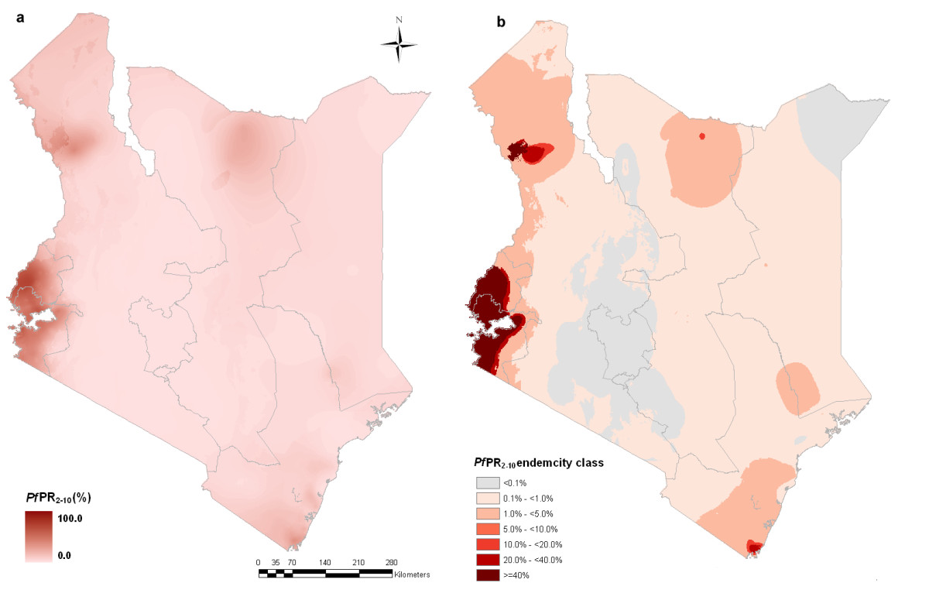
Spatial distribution of P. falciparum malaria in Kenya at 1×1 km spatial resolution. a) continuous posterior mean PfPR₂₋₁₀ prediction; b) endemicity classes: PfPR₂₋₁₀ < 0.1%; ≥0.1 and < 1%; ≥1 and <5%; ≥5 and <10%; ≥10 and <20%; ≥20 and <40%; ≥40%.

Figure 1 [7]

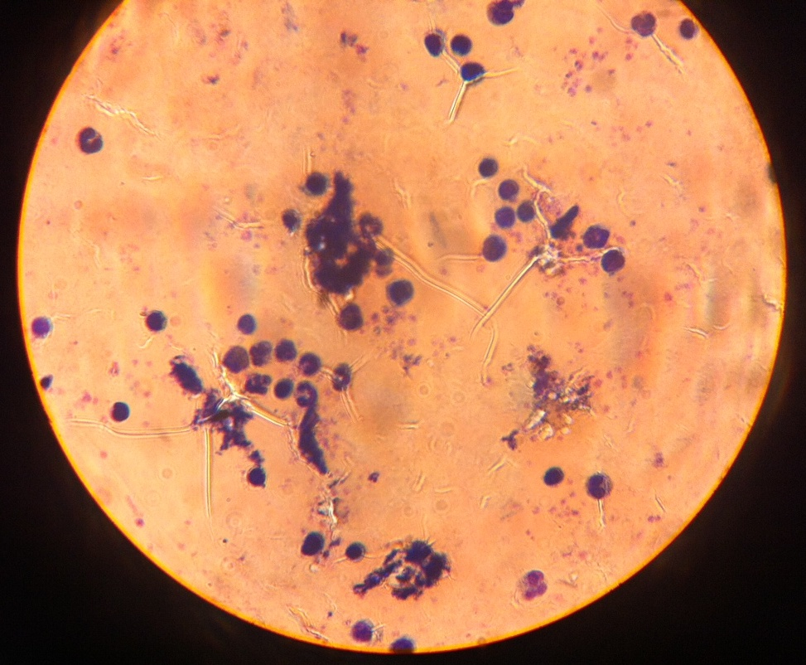
Figure 2 (unpublished photo) Malaria after AL consumption, Field stain, in Mundika, Western Kenya, March 2014.

