Common cold/URTI | Pneumonia
Virus. Antibiotics useless.  Normal children have 6-7 common colds a year and an adult 2-3.  Symptoms:  Cough  Running nose  Fever  Soar throat  Not so sick  3-5 days but can last longer  Treatment:  Symptomatic (paracetamol, nasal drops, cough syrup) | Bacteria. Antibiotic is needed.  Symtoms:  Cough  Increased respiratory rate  Respiratory distress  High fever  More sick-looking  Chest wall indrawings and nasal flaring on small children  Crepitations often heard when examining the lungs  Treatment: Antibiotics and symptomatic treatment  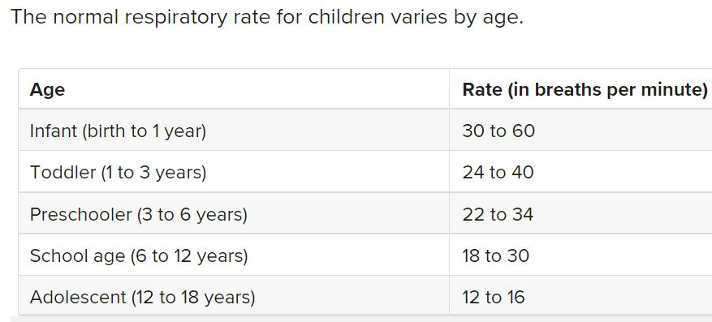
Why restrict the use of antibiotics?
- Reduce the increasing antimicrobial resistance.
- Every time a person takes antibiotics it disturbs the normal bacterial flora of the intestines and it takes some months up to half a year to restore the normal flora. Disturbed flora increases the risk of antibiotica associated diarrhea and clostridium-GE.
- Side effects common (nausea, diarrhea, dizziness, yeast infections like oral and vaginal candidosis).
- Risk of allergic reactions (mostly on CTX och penicillins).
- Cost money.
When antibiotics is needed (bacterial infections):
- Give as small spectrum as possible.
- Give the correct dose and duration (inform patients to continue the whole duration and only use it for the person it was prescribed).
To learn more: ReAct (www.reactgroup.org)

/Åsa Lundgren, November 2022, Rotary Doctors Sweden (asa.lundgren@gmail.com)

